Media Contact:
Landdis Hollifield, Events and Promotions Manager
Chimney Rock at Chimney Rock State Park
828-625-9611, ext. 1814
828-772-0052 cell
promoandevents@chimneyrockpark.com

For Immediate Release:

Chimney Rock State Park Hosts Earth Day Celebration on Saturday, April 21
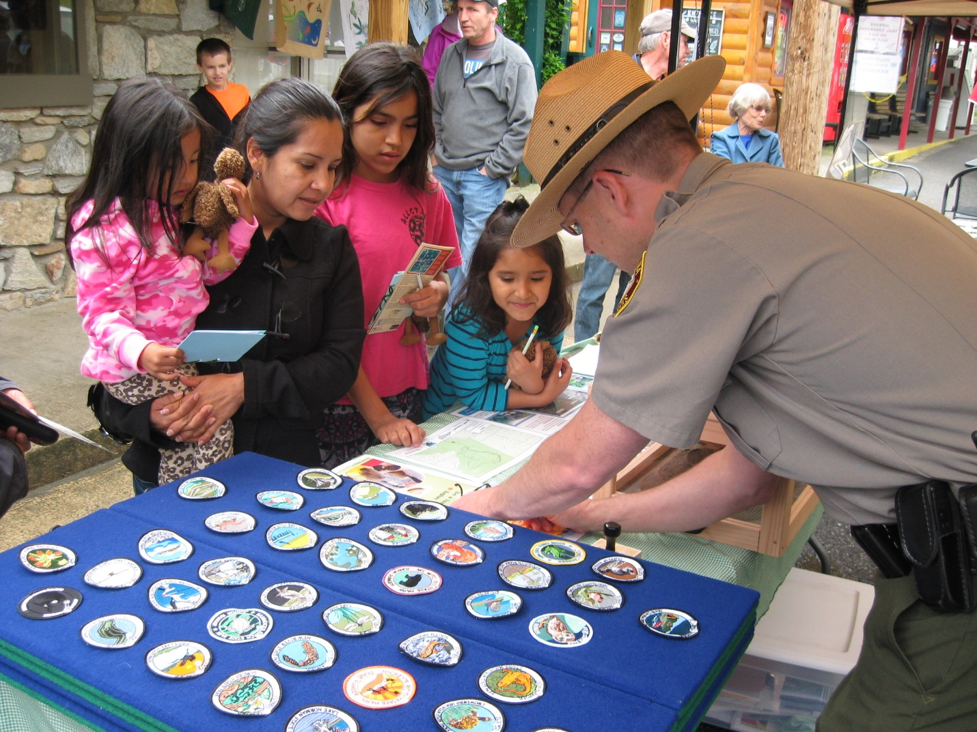
Local environmental educators will offer free activities, incentives and information

CHIMNEY ROCK, N.C. --- Chimney Rock State Park will celebrate the North Carolina Science Fair during this year’s Earth Day Celebration in Chimney Rock Village on Saturday, April 21, from 11 a.m. – 3 p.m. Local environmental educators, including Chimney Rock State Park Rangers, Chimney Rock Management, LLC naturalists, biologists and other environmental and outdoor enthusiast, will share the work they’re doing to protect the beautiful landscape of Western North Carolina. There will also be hands-on activities for kids all of all ages on the River Walk at 431 Main Street in Chimney Rock, near the Old Rock Café.

“Earth Day is a reminder that human action affects the environment and in turn affects humans,’ said Ranger Katherine Scheip. “Chimney Rock State Park’s Earth Day Celebration is a time to learn more about our natural environment through education, games, art and science. We hope to spark curiosity, action and fun with our event!”

Admission to the event is free, and youth ages 5-15 who collect six stamps through the event’s Discovery Trail program will earn a Rockin’ Discovery Pass, which allows them free admission to the Chimney Rock section of Chimney Rock State Park for one full year. Chimney Rock is the focal point of the greater Chimney Rock State Park. Chimney Rock State Park’s annual Earth Day events have become a popular attraction, with attendance growing steadily each year. This event will happen rain or shine.

Box 1:
Presenters include:
Appalachian State University,
Art Easel Rider
Asheville Greenworks
Blue Ridge EVE Club
Conserving Carolina
Civilian Conservation Corps
Chimney Rock Management, LLC.
Earth Shine Nature Programs
City of Hendersonville
Frugal Backpacker
Hands On!
Headwaters Outfitters
Holmes Educational State Forest
Kids in Parks Track Trail
KidSenses Museum
Lake Lure Environmental
Lake Lure Flowering Bridge
Mineral and Lapidary Museum
National Cave Rescue Commission
NC Arboretum
NC Clean Air
NC State Extension
NCDOT Roadside Environmental Unit
Rutherford County Soil & Water Conservation
Weed Action Coalition of Hickory Nut Gorge
Environmental Quality Institute

About Chimney Rock at Chimney Rock State Park
Chimney Rock at Chimney Rock State Park is a still-developing international outdoor destination located 25 miles southeast of Asheville on Highway 64/74A in Chimney Rock, N.C. It is recognized as one of the Southeast’s most iconic sites and popular travel destinations. The Park’s 535-million-year-old monolith called Chimney Rock is the centerpiece of the Park and can be accessed via the 500-step Outcroppings Trail. It offers guests 75-mile panoramic views of Hickory Nut Gorge and Lake Lure. The Park features one of the highest waterfalls of its kind east of the Mississippi River, Hickory Nut Falls, at 404 feet. Hickory Nut Gorge, one of the state’s most significant centers of biodiversity, is home to 36 rare plant species and 14 rare animal species. The Rumbling Bald section of the greater State Park off of Boys Camp Road in Chimney Rock is the only other area of the Park that is currently open to the public. A destination for travel groups, weddings and special events, the Chimney Rock section of the Park also hosts innovative educational programs for schools, homeschoolers, scouts and summer camps. Visit Chimney Rock’s website at chimneyrockpark.com.

