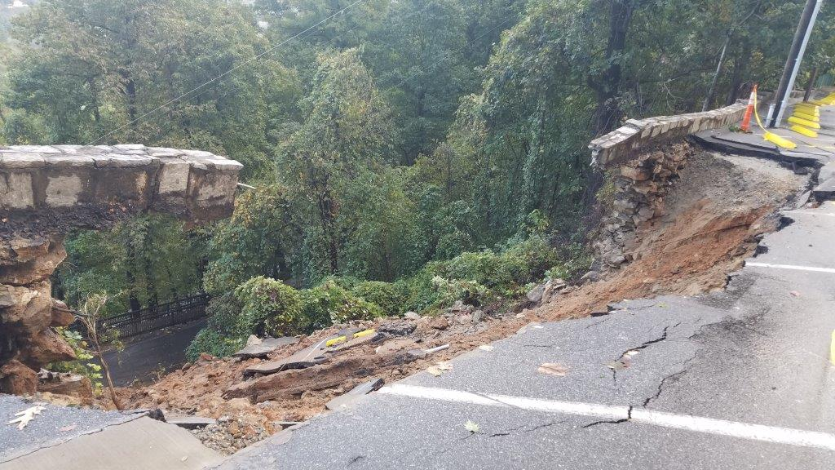
Chimney Rock at Chimney Rock State Park Closed Until Further Notice
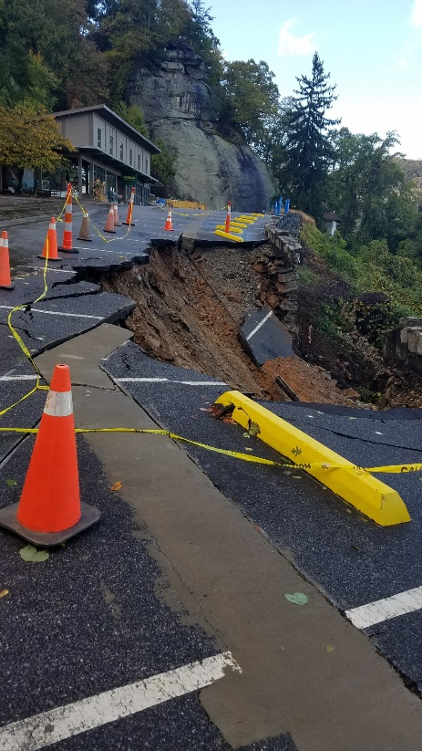
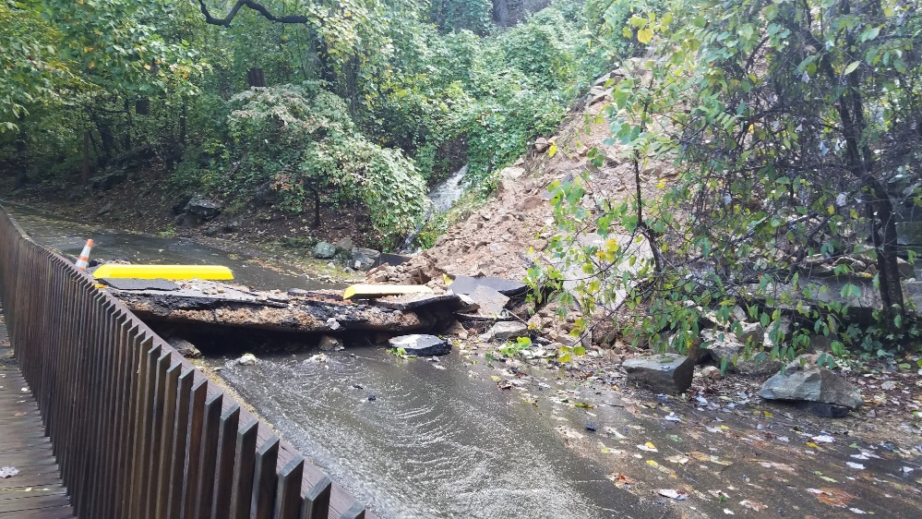
A retaining wall at the top parking lot in the Chimney Rock section of Chimney Rock State Park collapsed during heavy rainfall in the area yesterday, Monday, Oct. 23. Some of the debris washed to the road below. Crews are working to clear the roadway. DOT and contractors are assessing the situation to determine what needs to be done to fix the damage. Chimney Rock at Chimney Rock State Park will be closed until further notice. Go to chimneyrockpark.com or facebook.com/chimneyrocknc for updates. Thanks for your interest in the Park and your understanding.

