Media Contact:
Landdis Hollifield, PR & Promotions Manager
Chimney Rock at Chimney Rock State Park
828-625-9611 *814
828-772-0052 cell
prandevents@chimneyrockpark.com

For immediate release:
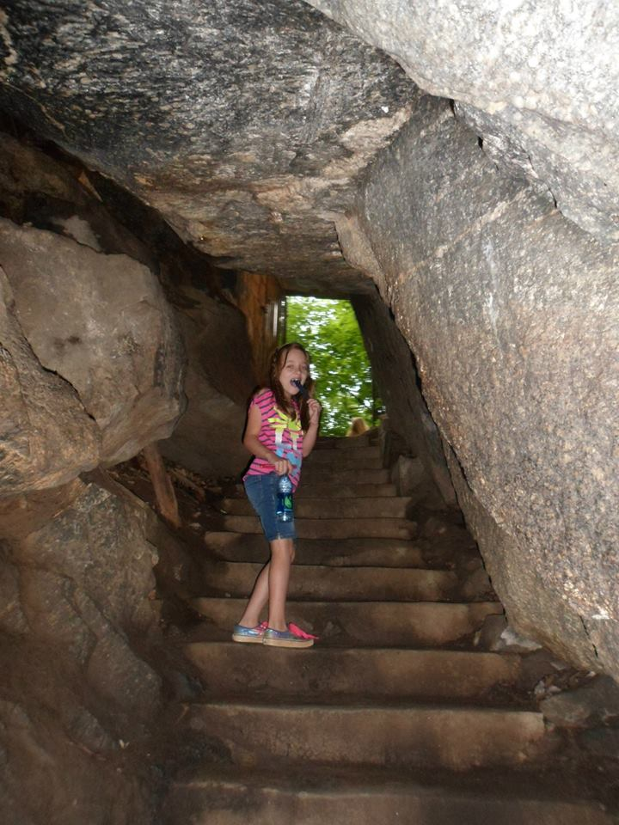

Capturing the perfect shot
  - Chimney Rock announces Spring Photo Contest Winners
Shots from Chimney Rock at Chimney Rock State Park’s Spring Photo Contest prove that a picture really is worth a thousand words.
Among the entries, there were photos of children gleefully celebrating, guests enjoying sweet treats and anoles sunning themselves on warm rocks.
Needless to say, picking the winners of spring’s contest was tough for the Park’s seasoned panel of judges. Luckily, the public helped make their job a little easier.
From Thursday, June 1, to Wednesday, June 7, the Park’s Facebook followers had the chance to like the photo that they thought deserved to win the People’s Choice Award. More than 200 individuals voted during this time, choosing Vaughn Loeffler’s photo “A Shot of Hickory Nut Falls”.
The image captures the sun glinting over the top of Hickory Nut Falls and shining through the leaves of trees located near the bottom of the 404-foot waterfall.
Loeffler will receive lunch for two at the Old Rock Café and a $20 gift certificate from Old Time Photo in Chimney Rock Village for his win.
When it came to choosing a first prize and second prize winner, judges chose two photos showing kiddos enjoying the Park.
Cathy de Siva’s photo called “Brooklyn in a Cave in Chimney Rock NC” was spring’s first-prize winner.
De Siva’s photo shows her daughter cooling off and exploring Gneiss Cave while enjoying a frozen teat.
For her win, she will receive an overnight getaway to Hickory Nut Gorge with a stay at the Historic 1927 Lake Lure Inn & Spa, two passes to Chimney Rock at Chimney Rock State Park, brunch for two at the Historic 1927 Lake Lure Inn & Spa and two tickets for Lake Lure Boat Tours.
The contest’s second-prize winner was Mark Kilm.
His photo “Success in making it to the top for spring break 2017” shows his children Riley and Abigail celebrating at the top of the Chimney.
For his win he receive a Chimney Rock prize package including two passes to Chimney Rock at Chimney Rock State Park, lunch for two at the Old Rock Café and two tickets to Lake Lure Boat Tours.
Shutterbugs that missed out on spring’s photo contest needn’t worry. The Park will continue its Seasons of Chimney Rock Photo Contest this summer. Entries for the contest will be accepted through Thursday, Aug. 31. Official contest rules and entry details can be found at chimneyrockpark.com under the “events” tab.
For a detailed listing of Park events and happenings, visit chimneyrockpark.com or Facebook.com/chimneyrockparknc.
About Chimney Rock at Chimney Rock State Park
Chimney Rock at Chimney Rock State Park is a still-developing international outdoor destination located 25 miles southeast of Asheville on Highway 64/74A in Chimney Rock, N.C. It is recognized as one of the Southeast’s most iconic sites and popular travel destinations. The Park’s 535-million-year-old monolith called Chimney Rock can be accessed via the 500-step Outcroppings Trail and offers guests 75-mile panoramic views of Hickory Nut Gorge and Lake Lure. The Park features one of the highest waterfalls of its kind east of the Mississippi River, Hickory Nut Falls, at 404 feet. Hickory Nut Gorge, one of the state’s most significant centers of biodiversity, is home to 36 rare plant species and 14 rare animal species. The Rumbling Bald section of the greater State Park off of Boys Camp Road in Chimney Rock is the only other area of the Park that is currently open to the public. A destination for travel groups, weddings and special events, the Chimney Rock section of the Park also hosts innovative educational programs for schools, homeschoolers, scouts and summer camps. Visit Chimney Rock’s website at chimneyrockpark.com.

Cutlines
#1
Vaughn Loeffler was the recipient of the People’s Choice Award during Chimney Rock at Chimney Rock State Park’s Spring Seasons of Chimney Rock Photo Contest.
#2
Mark Kilm’s photo of kiddos celebrating their trip to the top of the Chimney placed second in the spring contest.
#3
Cathy de Siva received first prize for her photo of a young explorer cooling down in Gneiss Cave.

