Media Contact:
Landdis Hollifield, PR & Promotions Manager
Chimney Rock at Chimney Rock State Park
828-625-9611 *814
prandevents@chimneyrockpark.com
Chimney Rock State Park to Open Skyline Trail
New trek offers stunning views of Hickory Nut Gorge, Lake Lure
Lush foliage, scenic views and shimmering cascades make Chimney Rock at Chimney Rock State Park’s new Skyline trail the perfect escape from the everyday rat race.
On Friday, Sept. 22, the Park will officially open the new Skyline trail, which can only be accessed by climbing more than 800 steps to the Skyline trailhead, located at Exclamation Point.
The new trail is named after the Park’s old Skyline trail, which led guests across the upper cliff face to the top of the Park’s waterfall. Sustainability issues with railings and bridges along the path led to its closure in 2008.
Since then, NC State Parks, Chimney Rock Management, LLC and the Friends of Chimney Rock State Park have worked together to bring back the upper trail in a more sustainable way.
“In 2015, it was determined that a new 1.1 mile trail would be built that would not require any structures or boardwalks,” said Chimney Rock State Park Superintendent James Ledgerwood. “The new Skyline trail travels along a higher route on the mountain which provides for sustainable natural resource protection and excellent views of Hickory Nut Gorge.”

Midway along the trail, hikers will encounter Peregrine’s Point, an overlook where visitors can have a picnic and enjoy amazing views of Exclamation Point and Lake Lure.

From there, hikers can journey to the end of the trail where cascades tumble over the mountainside to form 404-foot Hickory Nut Falls. Stunning views of the cascades and Hickory Nut Gorge make this the perfect finish for the newly-cut trail.
“Where can we go to do some more hiking?” “That’s one of the most frequently asked questions we get from our guests,” said Mary Jaeger-Gale, General Manager of the Chimney Rock section of the Park. “In addition to the Rumbling Bald access area, the new Skyline trail gives avid hikers another reason to come and spend more time in the Gorge. Many of our guests remember the former trails and have been waiting for them to reopen.”
In August, Annual Passholders were invited to take a sneak peak of the new trail on exclusive guided hikes.
Annual Passholder Pamela Paulus was glad to see the trail near completion. “It was a thrill,” said Pamela Paulus. “I’ve been waiting (for this trail to open for) years.”
Passholders were especially happy with how the new trail displays the splendor of the Hickory Nut Gorge.
“I’m very impressed by how you captured the natural beauty of the gorge,” said Passholder Angela Snyder.
State Parks looks forward to the trail’s official opening and future collaborations with Chimney Rock Management, LLC and the Friends of Chimney Rock State Park to expand public access to the Gorge.
“I am excited that the North Carolina State Park system continues to expand access to Chimney Rock Mountain and all of Hickory Nut Gorge,” said Ledgerwood. “With this success and continued support from our community, I hope that we can re-open some of the other highly loved and sought-after trails in the park.”

Hikers interested in exploring the new 2.2-mile roundtrip Skyline trail should wear sturdy shoes and bring plenty of water and snacks.
Since this is an extended hike, all hikers must start from the Skyline trailhead by 5 p.m. (EST) or by 4 p.m. during Daylight Savings Time. This will allow hikers ample time to explore and make it back to their car before the Park closes.
About Chimney Rock at Chimney Rock State Park
Chimney Rock at Chimney Rock State Park is a still-developing international outdoor destination located 25 miles southeast of Asheville on Highway 64/74A in Chimney Rock, N.C. It is recognized as one of the Southeast’s most iconic sites and popular travel destinations. The Park’s 535-million-year-old monolith called Chimney Rock can be accessed via the 500-step Outcroppings Trail and offers guests 75-mile panoramic views of Hickory Nut Gorge and Lake Lure. The Park features one of the highest waterfalls of its kind east of the Mississippi River, Hickory Nut Falls, at 404 feet. Hickory Nut Gorge, one of the state’s most significant centers of biodiversity, is home to 36 rare plant species and 14 rare animal species. The Rumbling Bald section of the greater State Park off of Boys Camp Road in Chimney Rock is the only other area of the Park that is currently open to the public. A destination for travel groups, weddings and special events, the Chimney Rock section of the Park also hosts innovative educational programs for schools, homeschoolers, scouts and summer camps. Visit Chimney Rock’s website at chimneyrockpark.com.

Cutlines: (COURTESY CHIMNEY ROCK AT CHIMNEY ROCK STATE PARK)
#1
At the end of the trail, hikers can enjoy the sight of cascades on their way to the end of the cliffside to form Hickory Nut Falls.
#2
The new trail features breathtaking views of the Hickory Nut Gorge.

Sidebar:
Learn more about the Skyline trail
Join Chimney Rock’s upcoming guided hike
On Saturday, Oct. 21, registered participants can tour Chimney Rock at Chimney Rock State Park’s newest feature, the Skyline trail, during a guided hike from 9 a.m. to noon.
A seasoned Park Naturalist will guide this hike through the ridgeline forest on top of Chimney Rock Mountain. Hikers can enjoy meandering along the newly-cut trek and the trail’s jaw-dropping views of the Hickory Nut Gorge and Lake Lure.
Cost is $22 per adult, $7 per Annual Passholder, $12 per youth (ages 5-15), $5 Rockin’ Discovery Passholder.
Space is limited to 15. Advance registration is required. To register, call 800-277-9611

#1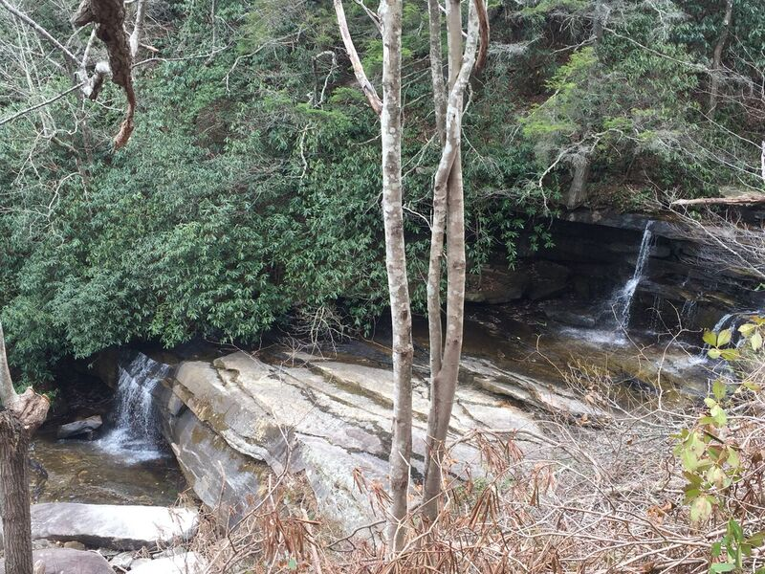#2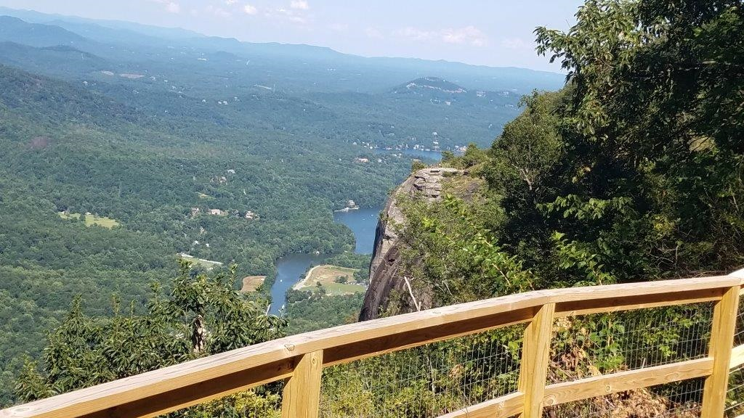
Peregrine’s Point

